**Test Case 4: Stale Expires Header Replacement**

Initiate proxy and client:

After modifying the “Expires header” to a past date to simulate a stale entry.

Running the client again:

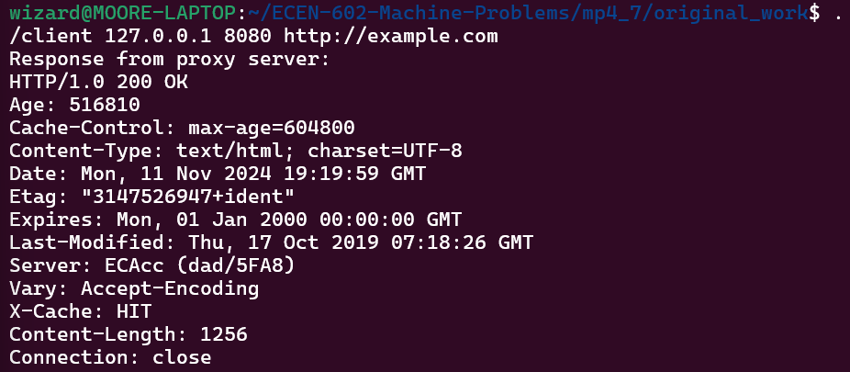

Seeing the output.html, the cache entry is replaced with fresh data, and the Expires header reflects a future date.

**Test Case 5: Stale Entry Without Expires Header Replacement**

Initiate proxy and client:

After modifying the last access time to a past date and removing “Expires” header.

Output.html confirms the fresh data replaces the outdated cache entry

**Test Case 6: Recent Access and Old Modification Cache Return**

Initiate proxy and client:

After removing the “Expires” header and modifying the last modification time to more than one month ago at two months ago, and setting the last access time to within the last 24 hours:

Running the client again:

Output.hmtl

The proxy correctly serves the cached data without fetching new data from the web server, as shown by the X-Cache: HIT header. Although the cache entry was accessed recently, the Last-Modified date remains as 09-11, while the Access Time in output.html updates to 2024-11-11, confirming recent access. The Age and Last-Modified headers indicate that the data is old but accessed recently, meeting Test Case 6’s requirements.